Rennes - Bretagne Atlantique

Pervasive RFID
SAD, Région Bretagne / RFID Pervasive, Labex CominLabs
Active Laboratories : INRIA Rennes & IETR, UMR CNRS 6164

  - Intermediate Activity Report, 2013-07-01 – 2014-03-14

Table des matières
I Introduction 2
II Pervasive RFID: Challenges and Goals 2
III Testbed Implementation: Mechanical AND RF SpecificationS 3
III.1 Mechanical specifications 3
III.2 RF specifications 4
IV Testbed Implementation: RFID SYSTEM Specification 4
IV.1 UHF RFID Readers: A Brief Survey 5
IV.1.1 Featuring RFID readers 5
IV.1.2 Readers’ software support 6
IV.1.3 Reader’s choice 6
IV.2 Common Reader Management Library (CRML) 7
IV.2.1 Introduction 7
IV.2.2 The modules of CRML 8
V Ongoing Work: RFID Tags Coupling AND NEW ANTENNA DESIGN 8
V.1 Antennas for RFID pervasive applications 8
V.2 Logical tag structures 9
V.3 Tags’ data combination 9
VI Conclusion 9
References 9

Introduction
This activity report summarizes the advancement status of the Pervasive RFID project from the beginning of the project (in July 1ST 2013) until March 2014. It mainly focuses on the RFID testbed implementation, which corresponds to the first task of the project (Task 1.1). The RFID testbed is a key platform of the project as it allows to:
- Study and characterize challenging RFID situations;
- Test novel RFID protocols that combine physical solutions (i.e., mechanical or electromagnetic solutions) with logical solutions (e.g., tag coupling);
- Design innovative RFID antenna systems that fit challenging RFID situations.
The RFID testbed is formed of two major parts, viz., a mechanical part and a RFID part. The former part is mainly about the structure of the testbed and a number of motion engines that enable moving RF antennas and tags. The latter part concerns the RFID reader and its associated antennas, as well as RFID tags.
Next, we first recall the motivations and the goals of the project. Then, we respectively detail the aforementioned parts of the RFID testbed. Finally, we briefly sketch an overview of the ongoing work and give concluding remarks.

Pervasive RFID: Challenges and Goals
In the Pervasive RFID project, we focus on ad hoc RFID situations with no prior knowledge about the tags to be read (notably their number and their positions), neither the environment (i.e., RF friendly or unfriendly environment). Therefore, challenging RFID situations can be faced, e.g., tags are randomly placed in positions and orientations that are unfavorable for RF backscattered communication. To cope with such situations, a number of RFID problems have to be addressed, thus enabling the adoption of RFID technologies in pervasive environments. These challenges can be summarized as follows:
- Tags are outside the reader’s RF field: The distance between the reader and the tags is far (with respect to the emitted RF power) so that the tags are considered outside the reader’s RF field.
  - RF field black hole: Tags are placed into RF shortage zones representing empty holes within the reader’s RF field.
  - Weak backscattered radiation: The energy harvested by tags is not enough to enact backscattered communication.
  - Backscattered radiation in a non-covered direction: The radiation backscattered by tags is emitted outside the reader’s RF field.
  - Tag mutual coupling: When RFID tags are closely-spaced, they may harvest the energy scattered form each other, thus reducing the radiation backscattered to the reader.
  - Tag masking: A tag may be hidden by some RF-unfriendly material or other tags.
  - MAC level collisions: The density of tags within the reader’s RF field is high so that multiple tags communicate simultaneously with the reader, thus causing collisions during communication with the reader.
To cope with the aforementioned RFID problems, the Pervasive RFID project advocates two kinds of solutions , which were classified in this first phase of the project (see Figure 1).
- Physical solutions, which consist in properly configuring (i) the reader’s parameters (such as the emitted RF power, the number of antennas, their sequence and their combination, as well as tag singulation parameters), and/or (ii) the position (i.e., polar coordinates) of RF antennas (under the assumption that they can be moved using proper motion engines).
- Logical solutions, which consist in logically coupling RFID tags, such that when a subset of tags is read, the missing ones can be determined. Further details about tag coupling are given in Section V.

Figure 1. Taxonomy of the solutions put forward by the Pervasive RFID project to enhance the tag reading capability of RFID systems

Testbed Implementation: Mechanical AND RF SpecificationS

Mechanical specifications
The main characteristics of test-bed have been defined to provide a maximum capabilities (or scenarios) for pervasive environment using RFID technology. The scheme of test-bed is shown and described below.
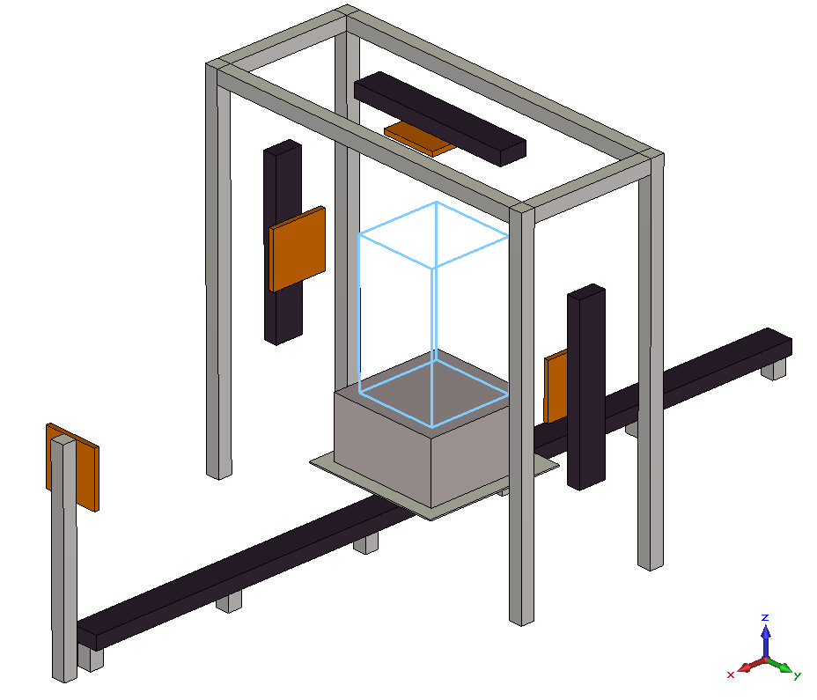
Structural scheme of RFID test-bed
The automated test-bed is made with a portal and several motorized linear guide rails carrying RFID antennas. This test-bed exhibits a lot of degree of freedom (translation, rotation, …) along different axes (x,y,z), whichs allow moving RFID tag groups or tagged objects across the radio coverage of the portal to enhance the reading. These different guide rails are controlled remotely in order to modify geometry, position, etc. to improve the RFID reading. The other objective is to enable automation since these types of measurement requires statistical datas. Each rail is defined with a good accuracy in order to achieve a very good reprodicibility of experimentations. The dimensions of this portal are defined for industrial applications (dock doors, etc.) The guide rail located on the ground has a length of 6 meters and the portal has the size of 2.6x2.6x1.1m³. A call for tender was issued for the realization of this test-bed in order to find the best provider.

RF specifications
The RF part of this test-bed includes a RFID reader and several antennas located on the portal to illuminate the RFID tags. The reader will be a commercial one whose characteristics as RF parameters (power…) or anti-collision protocols can be modified during the reading process in the portal. For the first part of experimentations, classical antennas will be used first. Then they will be replaced by more complex antennas to enhance the collected informations from RFID tags. During the displacement of tagged objects, antennas can be switched (on/off) to find the best RF configuration.

Testbed Implementation: RFID SYSTEM SpecificationS
Pervasive RFID addresses RFID applications that require long read ranges and use low cost RFID tags (notably passive tags). Accordingly, here we focus on UHF (Ultra High Frequency) RFID readers for the testbed implementation. Below, we present a brief study of some UHF RFID readers toward selecting one among them. After that, we introduce a software library to manage and control these readers.

UHF RFID Readers: A Brief Survey
This section presents a brief overview of some UHF RFID readers (viz., Alien 9900+, Motorola FX9500, Impinj speedway revolution and FEIG LRU-3000/3500) that are eligible to be used for the RFID testbed implementation. The aim of this section is to compare these readers from two points of view: (i) their configurability, i.e., the number and relevance of configurable parameters, thus enabling to devise custom RFID protocols, and (ii) the software support underpinning these readers, notably the supported development technologies (languages, libraries and tools), which facilitates the implementation of a RFID management system for the testbed.

Featuring RFID readers
Table 1 summarizes the key features of the considered readers. It focuses on (i) the tag reading configurable parameters and (ii) tag information supported by each reader. Table 1 further highlights the features deemed important with respect to the solutions aimed at by Pervasive RFID (see Section II). These features are contained in the coloured boxes of Table 1 (highly important features are labelled “important”, whereas less important ones are labelled “optional”).
Reader |  | Alien® 9900+ | Motorola® FX9500 | Impinj® speedway revolution | FEIG® LRU-3000/3500
Supported Features
Reading Protocol Parameters | Autonomous / Intelligent mode
 | RF Power (important)
 | Session
 | Tag Population Estimate | X | X |  | X
 | Cycles (frames) (important) |  | X | X | X
 | Count (inventories) (important) |  | X | X | X
 | Q Parameter (initial slots) (important) |  |  | X | X
 | Mask/Filter (with Include/Exclude feature or using multiple filters) (important)
 | (Inventory) Tag persist time |  |  | X
 | (Inventory) Antenna activation/deactivation |  | X
 | RSSI filter (important) |  |  | X | X
 | Speed filter |  |  | X | X

Tag Information | TID
 | EPC
 | User Data
 | Discovery Time (FirstSeenTime) (optional) |  | X |  | X
 | Last Seen Time (optional) |  |  |  | X
 | Singulation count (SeenCount) |  | X |  | X
 | Antenna
 | Phase Angle (In Radians) | X |  |  | X
 | Channel (In Mhz) | X | X |  | X
 | Range/Distance | X |  | X | X
 | RSSI (important)
 | Speed (optional) |  | X | X | X
 | Smooth speed (optional) |  | X | X | X
 | Smooth position (optional) |  | X | X | X
 | Direction (optional) |  | X | X | X
Table 1. Featuring RFID readers

Readers’ software support
Table 2 gives an overview of the software support underpinning each RFID reader. The table describes the supported software development languages and frameworks (i.e., application development, OS and hardware frameworks), as well as the distribution of the software libraries supplied for each reader.
Reader |  | Alien® 9900+ | Motorola® FX9500 | Impinj® speedway revolution | FEIG® LRU-3000/3500
API/SDK features
Supported languages |  | - .Net  - Visual Basic 6  - Java | - .Net  - C | - .Net  - C++  - Java | - .Net  - Visual basic 6  - C, C++  - Delphi 5  - Java
Supported frameworks | Application Development  (further to the languages’ inherent SDKs and IDEs) | - Microsoft BizTalk RFID  - XML technology | - Microsoft BizTalk RFID | - Java LTK¹ | - LabVIEW³  - XML technology
 | OS | - Windows  - Linux | - Windows | - Windows  - Linux  - Mac OS X (using Mono²) | - Windows 9x/NT4/2000/XP  - Windows mobile  - Linux
 | Hardware | N/A | N/A | N/A | - USB Readers³
Distribution |  | - Binary distribution (with docs, sample application and coding samples) | - Binary distribution (with docs, sample application and coding samples) | - Binary distribution (with docs, sample application and coding samples) | - Binary distribution (with docs, sample application and coding samples⁵)
Table 2. Software support for RFID readers

Reader’s choice
The choice of a RFID reader to conduct custom experiments in the context of the Pervasive RFID project is not obvious. Indeed, we do not have an accurate idea about the readers’ performance, neither about their internal logic (notably their anti-collision protocols). Still, the information presented above can guide the reader’s choice.
Table3 summarizes the relevance of the studied readers with respect to two main criteria: (a) their configurability, and (b) their underpinning software support.

Criteria | Configurability | Software support
Reader
Alien 9900+ | ++ (highly configurable) | ++ (rich software support)
Motorola FX9500 | + (simple configurability) | + (simple software support)
Impinj speedway revolution | + (simple configurability) | ++ (rich software support)
FEIG LRU-3000/3500 | - (very basic configurability) | +++ (notable software support)
Table 3. Summarizing the readers’ choice criteria

Compiling the above table enables featuring two readers. First, the Alien 9900+ reader represents a convenient choice to conduct custom RFID experiments, as it is highly configurable and has a rich software support. Additionally, it provides tag information (viz., the tag speed, smooth position and direction) that are deemed important for RFID applications dealing with moving tags. Second, the Impinj speedway revolution reader could be an alternative choice. Its intelligent reading mode represents a nice reference to evaluate the efficiency of RFID protocols resulting from the Pervasive RFID project.

Common Reader Management Library (CRML)

Introduction
As detailed in the previous section, multiple RFID readers are eligible to be used for the testbed implementation. Each reader can be programmatically controlled using a number of software systems and languages. To cope with the heterogeneity of RFID readers and their underlying software systems, we introduce a Common Reader Management Library (CRML) for RFID systems.
CRML is a generic Java library that enables the management of heterogeneous RFID readers using a common interface. It allows RFID middleware and applications to interact with RFID readers in a transparent way without dealing with their specifics (e.g., low level parameters).

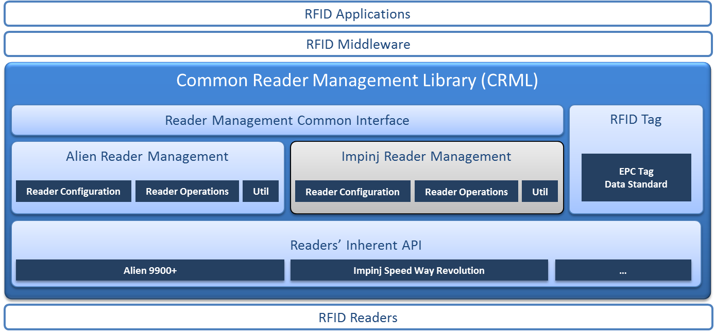
Figure 1. CRML architecture

Overall, the CRML library represents a preliminary contribution of the Pervasive RFID project. Further under-development contributions are described below.

Ongoing Work: RFID Tags Coupling AND NEW ANTENNA DESIGN
Current RFID systems are not utterly reliable as they may fail to read all the tags present in their RF field (particularly when dealing with bulk tag reading in messy situations), which leads to the loss of data (notably the ID) stored within tags. To cope with data loss brought about by tag reading failures, we will use a two level approaches: 1) developing new antenna design and 2) using logical coupling between the tags, which consists in introducing logical links between tags, thus enabling to determine missing tags by reading only a subset of them. The former aims at improving the tag readability at a physical level, and is application independent. The latter approach targets RFID applications dealing with static tag batches, i.e., group of tags written and read together without loss or addition of tags. Under this assumption, tag coupling enables providing feedback about the missing tags (i.e., their IDs) in order to guide and improve tags’ reading, and/or report reading failures with detailed information about the missing tags. Below, we introduce two approaches for tag coupling.

Antennas for RFID pervasive applications
We develop currently new antenna systems to provide the best reply to RFID reading in unfavorable situations. One of main problems due to the RF coverage has been highlighted in the reduction of tag reading and will be treated during the next part of the project. To address this problem, we propose to develop a versatile antenna in terms of polarization and space diversity. Different configurations (shape of radiation pattern or polarization) will be defined to enhance the tag reading ratio.

Logical tag structures
RFID tags can be coupled by introducing logical structures (e.g., planar and hierarchical structures) that connect tags together. Such structures can be implemented by assigning specific values to tags’ identifiers, thus forming ‘follow-up’ links among tags. Accordingly, when reading a subset of tags, the remaining part of the structure can be deduced. For instance, RFID tags representing objects in a container can be modelled using a hierarchical structure [3], i.e., tree structure. A prominent idea to fulfill such a structure is to use prime numbers as tag identifiers [2].

Tags’ data combination
A second approach to RFID tag coupling is to consider tags as data carriers (i.e., data storage nodes). Hence the problem of improving the tag reading capability of RFID systems can be expressed as providing reliable data storage over unreliable nodes (i.e., RFID tags). In the literature (notably in the distributed data storage community), several techniques have been put forward to enable reliable data storage. One technique towards this purpose is to introduce data redundancy that is mutually stored within nodes. In our context, the redundant data is established by ‘mixing’ tags’ identifiers together, thus forming reciprocal pointers among tags.

Conclusion
The aforementioned tag coupling approaches (i.e., logical tag structures and tags’ data combination) are implemented, and preliminary experimental evaluations are carried out to assess their efficiency. Extensive experiments will be further performed using the RFID testbed. To date, a specification of the testbed is established, a call for tenders has been published, and an industrial provider is selected to supply the equipment and its initial setup.

References
- GS1 EPC Tag Data Standard 1.7: http://www.gs1.org/sites/default/files/docs/tds/tds_1_7-Std.pdf
- Davy Preuveneers, Yolande Berbers, Prime numbers Considered Useful: Ontology Encoding for Efficient Subsumption Testing, Technical Report (CW Reports), volume CW464, Department of Computer Science, K.U.Leuven, Leuven, Belgium, October 2006.
- A. Sinha, Y. Glouche and P. Couderc. Distributed tree structure for composite physical objects. 5th International Conference on Ambient Systems, Networks and Technologies, June 2014 [Accepted for publication]
- O. Roncière, S. Collardey, R. Sauleau, N. Ben Mabrouk, P. Couderc. Diversity contribution of a versatile UHF RFID antenna system in portal applications. EuMC, European Microwave Week, Roma, Italy, oct. 2014 [submitted].

